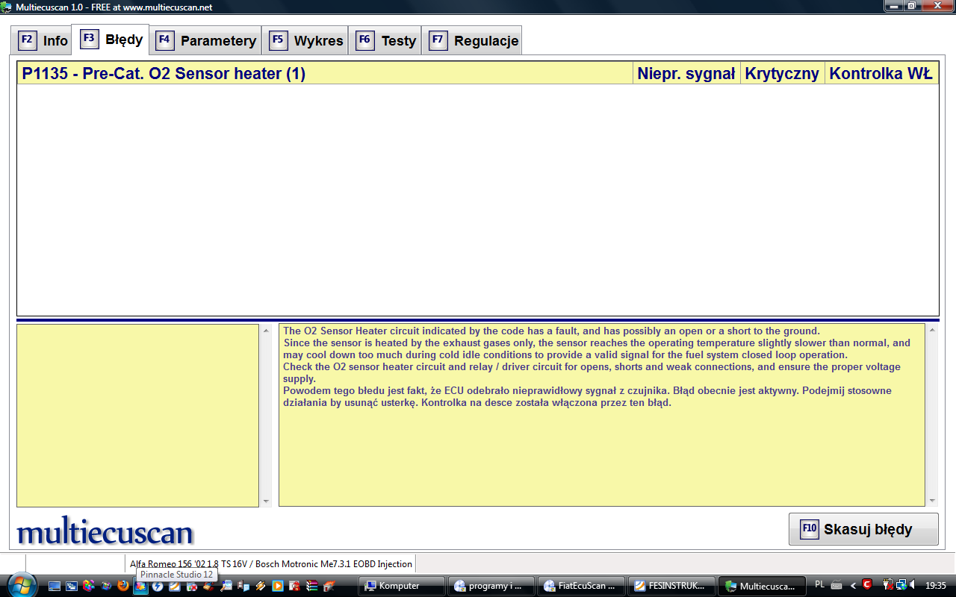

The O2 Sensor Heater circuit indicated by the code has a fault, and has possibly an open or a short to the ground.
Since the sensor is heated by the exhaust gases only, the sensor reaches the operating temperature slightly slower than normal, and may cool down too much during cold idle conditions to provide a valid signal for the fuel system closed loop operation.
Check the O2 sensor heater circuit and relay / driver circuit for opens, shorts and weak connections, and ensure the proper voltage supply.
Powodem tego błedu jest fakt, że ECU odebrało nieprawidłowy sygnał z czujnika. Błąd obecnie jest aktywny. Podejmij stosowne działania by usunąć usterkę. Kontrolka na desce została włączona przez ten błąd.

